**Interfacing LEDs to 8051 and displaying Different Patterns**

**Lab #02**



Spring 2022

CSE-307L Microprocessor Based system Design

Submitted by: **Ashfaq Ahmad**

Registration No: **19PWCSE1795**

Class Section: **B**

“On my honor, as student of University of Engineering and Technology, I have neither given nor received unauthorized assistance on this academic work.”

Student Signature: ______________

Submitted to:

**Dr: Aber Irfan sab**

**July** 25, 2022

**Department of Computer Systems Engineering**

**University of Engineering and Technology, Peshawar**

**Task 01:** Even and Odd LEDs glow.

**Source Code:**

ORG 0000H

Start:

 MOV R1,#0AAH

 MOV P1,R1

 ACALL Delay

 MOV R2,#55H

 MOV P1,R2

 ACALL Delay

 SJMP Start

Delay:

 MOV R3,#250  ;2 MC

AGAIN:

 MOV R4,#250  ;2MC

HERE:

 NOP          ;1 MC

 NOP          ;1MC

 DJNZ R4,HERE  ;(1+1+2)x250=1000Mc internal loop (here)

 DJNZ R3,AGAIN ;(2+2+1000) x 250= 251000+2+2=251004=251 msec

 RET            ;2 MC

 END

ORG 0000H

Start:

 MOV R1,#0AAH

 MOV P1,R1

 ACALL Delay

 MOV R2,#55H

 MOV P1,R2

 ACALL Delay

 SJMP Start

Delay:

 MOV R3,#250  ;2 MC

AGAIN:

 MOV R4,#250  ;2MC

HERE:

 NOP          ;1 MC

 NOP          ;1MC

 DJNZ R4,HERE  ;(1+1+2)x250=1000Mc internal loop (here)

 DJNZ R3,AGAIN ;(2+2+1000) x 250= 251000+2+2=251004=251 msec

 RET            ;2 MC

 END

**Output:**

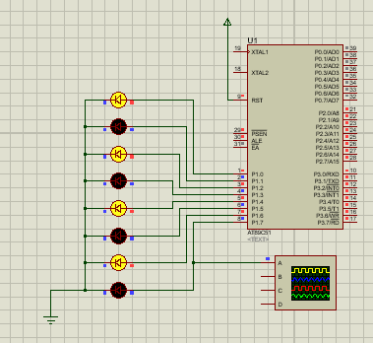

**Graph:**

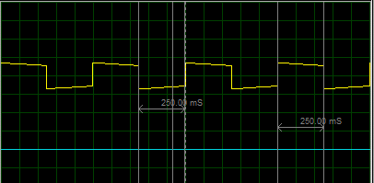

**Task02:** All ON and OFF LEDs pattern.

**Source Code:**

ORG 0000H

Start:

 MOV R1,#00H

 MOV P1,R1

 ACALL Delay

 MOV R2,#0FFH

 MOV P1,R2

 ACALL Delay

 SJMP Start

Delay:

 MOV R3,#250

AGAIN:

 MOV R4,#250

HERE:

 NOP

 NOP

 DJNZ R4,HERE

 DJNZ R3,AGAIN

 RET

 END

ORG 0000H

Start:

 MOV R1,#00H

 MOV P1,R1

 ACALL Delay

 MOV R2,#0FFH

 MOV P1,R2

 ACALL Delay

 SJMP Start

Delay:

 MOV R3,#250

AGAIN:

 MOV R4,#250

HERE:

 NOP

 NOP

 DJNZ R4,HERE

 DJNZ R3,AGAIN

 RET

 END

**Output:**

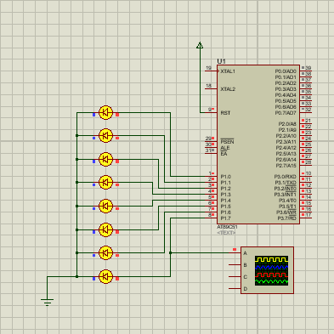

**Task03:** First Four LEDs ON and Last Four OFF.

**Source Code:**

ORG 0000H

Start:

 MOV R1,#0F0H

 MOV P1,R1

 ACALL Delay

 MOV R2,#0FH

 MOV P1,R2

 ACALL Delay

 SJMP Start

Delay:

 MOV R3,#250

AGAIN:

 MOV R4,#250

HERE:

 NOP

 NOP

 DJNZ R4,HERE

 DJNZ R3,AGAIN

 RET

 END

ORG 0000H

Start:

 MOV R1,#0F0H

 MOV P1,R1

 ACALL Delay

 MOV R2,#0FH

 MOV P1,R2

 ACALL Delay

 SJMP Start

Delay:

 MOV R3,#250

AGAIN:

 MOV R4,#250

HERE:

 NOP

 NOP

 DJNZ R4,HERE

 DJNZ R3,AGAIN

 RET

 END

**Output:**

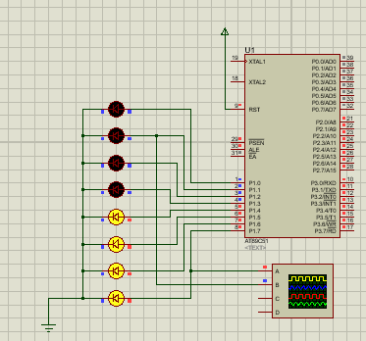

**Graph:**

